Dis-Eur-Spain-Neolithic-Goddess-Seated on throne

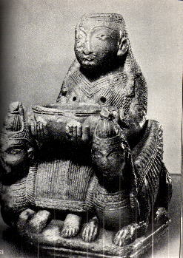

Fig. 8A5) Zooanthropomorphic sculpture in alabaster. It is the " Goddess of the fertility "; sitting over a throne without backrest and flanked from two sphynx (that have an ulterior meant in the cult). From the pierced breasts, liquids in the little basin flowed.She supports the basin with her hands.   
This divinity is directly connected to Neolithic goddesses Mothers, and, therefore, to the paleolithic venus.   
Size: height cm. 17.8 - width cm. 10.6 - thickness cm. 12.7.   
Origin: Grave 20, Necropolis Tutugi, Jail, Granada, Spain.   
National Archaeological Museum, Madrid, Spain.